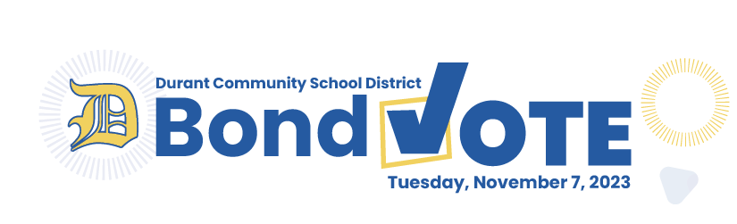INSERT IMAGE 01
Why are we voting?
Over the last few years, following a thorough assessment of our building in 2018, the Durant Community School District has been addressing deferred maintenance issues, such as replacing the roof and windows in the middle school wing and repairing flooring. There is more work to be done, though, to ensure our building will serve future generations of Wildcats as it has for nearly 100 years.

Over the course of more than a year, a community-based facility advisory committee considered the results of the facility assessments and past facility plans and arrived at a proposed solution that will address the most critical facility needs at our district. The plan includes overall updates to classrooms and improved security at entrances. The original 1936 gym will be replaced with a new gym in the same location that will be large enough for practices and middle school competitions.

The project will be funded by a general obligation bond and a Physical Plant and Equipment Levy (PPEL), which requires a public vote.

What does the project include?
- Replace 1936 Gym: Demolish existing gym and replace with new locker rooms and new seating
- Science & Art Classrooms: Update aging equipment and furnishings
- Elementary office: Relocate to elementary wing for improved wayfinding and security
- General updates throughout building including paint, flooring, and ceilings
- Update heating and electrical systems to extend life
- Add sprinkler system for safety
- Replace windows

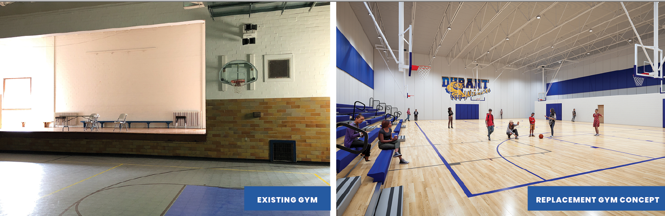INSERT IMAGE 02

How will we pay for it?
The project will be funded through two sources: a general obligation bond and a Physical Plant and Equipment Levy (PPEL). The bond will increase the property tax rate by $2.70 per $1,000 of taxable value. The $1.34 PPEL will come from a combination of property taxes and income surtax. Legally, as much as $1.23 of the $1.34 can come from income tax, leaving just 11 cents as a property tax rate increase. The exact amount will be re-evaluated each year, but the board intends to leverage the maximum amount of income tax annually to reduce the impact on property owners.
How much will my taxes go up?
The total projected property tax rate increase for both the bond ($2.70) and PPEL ($.11) is $2.81 per $1,000 of taxable value. Keep in mind the final taxable value of your property is a percentage of its assessed value after credits. Below are examples of how taxes will be affected for both residential and agricultural property.

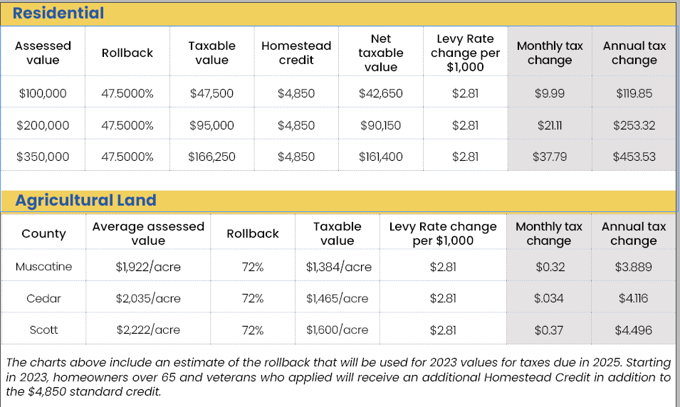 (INSERT IMAGE 03)
Durant’s tax levy has routinely ranked well below peer districts. By being fiscally responsible, the district has been able to keep Durant’s levy rate low compared to peer districts. After the bond passes, Durant’s rate will still be lower than many comparable districts.
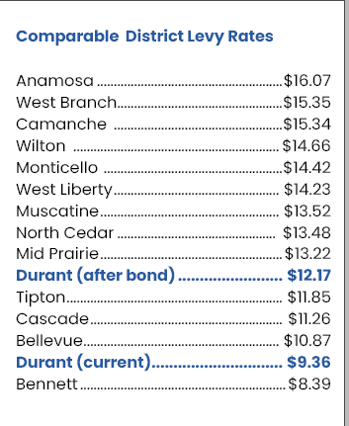 (INSERT IMAGE 04)

What will the ballot say?
On November 7, 2023, the Durant Community School District will ask voters within the district boundaries to vote on two ballot questions that will fund renovations and replacement facilities to the district’s campus.
“Shall the Board of Directors of the Durant Community School District in the Counties of Cedar, Muscatine, and Scott, State of Iowa, be authorized to contract indebtedness and issue General Obligation Bonds in an amount not to exceed $11,060,000 to provide funds to renovate, remodel, repair, improve, expand, furnish and equip portions of the existing building, including gymnasium spaces, classrooms, HVAC and electrical systems, and administrative office spaces, including security improvements?”

How do I vote?
EARLY: Vote early in person at the auditor in your county of residence during business hours Monday through Friday from October 18 through November 6.
Absentee: Request an absentee ballot from your county’s auditor. Print an absentee ballot request form online: https://sos.iowa.gov/elections/pdf/absenteeballotapp.pdf
Absentee ballot requests must be received by the auditor by October 23. Once a request form has been submitted the auditor will mail you a ballot. Completed ballots must be received by the auditor by 8 p.m. on election day. Ballots can also be surrendered at your polling location on election day.
Election Day: November 7, 2023
On election day from 7 a.m. to 8 p.m., eligible voters may vote at their assigned polling place. Search for your polling place using this link: https://sos.iowa.gov/elections/voterreg/pollingplace/search.aspx or contact your county auditor’s office.
- Cedar County Auditor: 563-886-3168
- Scott County Auditor: 563-326-8683
- Muscatine County Auditor: 563-263-5821

ADDITIONAL QUESTIONS
Why should we invest in our facilities?
School facilities are integrally tied to a community’s economic vitality. According to a recent study by real estate search engine Trulia and Harris Interactive, the majority (57 percent) of parents with children under 18 would pay above listing price to live in the neighborhood with ideal schools. As districts around us improve their facilities and the community continues to look to the future, our school facilities will play a critical role in our community’s viability.
What will the renovations and additions look like?
We know everyone is eager to know details about the improvements. That’s why OPN Architects has developed a design concept of the gym. We want to give our community an idea of what it could look like. But we want to stress that these are just initial ideas. There’s a very real possibility that the final design won’t look anything like the picture. After the bond passes and as part of the design process, OPN will spend time getting to know the community’s collective vision for this project, how the spaces will be used and what each space should provide. Final dimensions, exact layout, and general aesthetic, as well as how existing spaces will be repurposed, will be determined at this point in the process. These details will be determined by a core group identified by the school district.
When will the project be complete?
Once the bond passes, OPN Architects will start the design process, which includes detailed conversations about space needs, adjacencies, and aesthetic preferences. We would likely bid the project in spring 2024. Construction would be complete for the 2025-2026 school year.
Why can’t we pay for the addition without a bond vote?
School district funding is a complicated issue. While generally it is considered wise to save money for a rainy day – or in this case a large expense – school districts are not legally allowed to stockpile large savings accounts. As a protection for taxpayers, they are encouraged by law to operate in such a way that they spend all that they bring in each year. This general fund is used to pay salaries and buy supplies. Think of it like a checking account for day-to-day expenses.
General Obligation Bonds are designed to allow districts to take on larger-scale projects. In response to voter feedback following the March 2023 vote, the district board and leadership have elected to reduce the total project cost. Additionally, the total general obligation bond amount has been reduced and will be supplemented through an income surtax PPEL. The district will be able to use the 1-cent sales tax (SAVE) fund for unforeseen repairs like a broken window or to replace a piece of equipment.
Does the project address safety and security?
The plan will include improvements such as visual phones and electronically locking doors at the High School and Middle School entrances. Moving the elementary school entrance to the district office location will also result in less traffic from the main entrance to the elementary wing.
Replacing the existing bleachers and locker rooms in the old gym will also improve safety as neither are currently code compliant. The plan will also include ADA improvements such as non-code compliant ramps in the building. Additionally, the building will have a fire sprinkler system, which will greatly improve overall safety.
What happens if the projects go over budget?
The district is not allowed to bond beyond the amount approved by voters. Of course, anyone who has ever taken on a construction project no matter how big or small knows that there are always unforeseen costs. In the architecture and construction industry, these are called contingencies. A contingency budget is built into the overall budget. Typically, at this point in the project, this is around 20% of the total project budget. This means that our budget is built to be flexible to accommodate unforeseen situations. Throughout the design process, there will be regular cost estimates, each with more detail that helps the design team and district stay aligned with the budget.
Will current supply chain issues affect our project?
OPN has a great deal of experience working on publicly bid projects, including many new and renovated school buildings. We have relationships with local contractors who are all well-versed in procurement phasing, especially due to current supply chain issues.

